## Experiment 6: Shell Loops

### Name: Tushita Sharma Roll No.: 590029121 Date: 2025-09-23

### Aim:

* To understand and implement shell loops (for, while, until) in Bash.
* To practice loop control constructs (break, continue) and loop-based file processing.

### Requirements

* A Linux system with bash shell.
* A text editor (nano, vim) and permission to create and execute shell scripts.

## Theory

Loops allow repeated execution of commands until a condition is met. Common loop constructs in Bash include for (iterate over items), while (repeat while condition true), and until (repeat until condition becomes true). Loop control statements like break and continue change the flow inside loops. Loops are essential for automating repetitive tasks such as processing multiple files, generating sequences, and collecting user input.

## Procedure & Observations

## Exercise 1: Simple for loop

### Task Statement:

Write a for loop that prints numbers 1 to 5.

### Command(s):

for i in 1 2 3 4 5; do  
 echo "Number: $i"  
done

### Output:

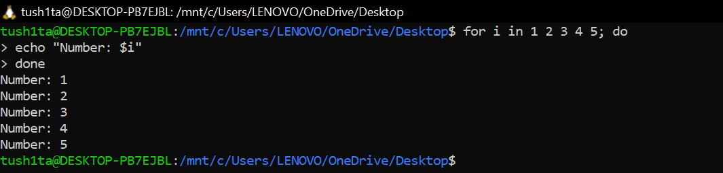

## Exercise 2: for loop over files

### Task Statement:

Process all .txt files in a directory and count lines in each.

### Command(s):

for f in *.txt; do  
 echo "File: $f - Lines: $(wc -l < "$f")"  
done

## Output:

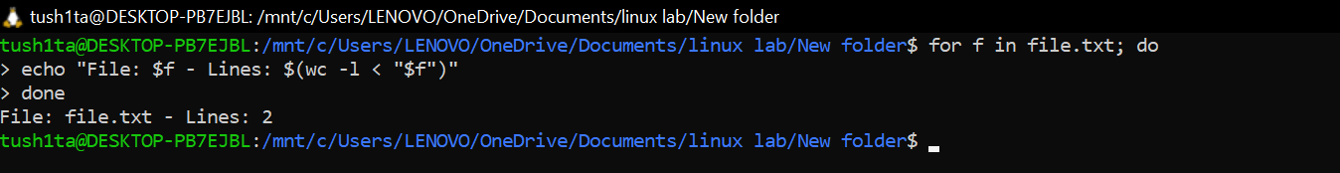

## Exercise 3: C-style for loop

### Task Statement:

Use arithmetic C-style loop for numeric iteration.

### Command(s):

for ((i=0;i<5;i++)); do  
 echo "i=$i"  
done

## Output:

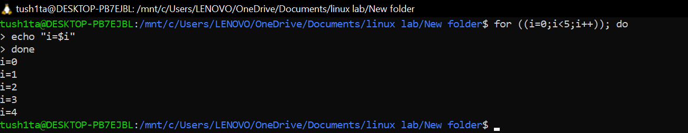

## Exercise 4: while loop and reading input

### Task Statement:

Write a while loop that reads lines from a file or from user input.

### Command(s):

# Read from file  
while read -r line; do  
 echo "Line: $line"  
done < sample.txt  
  
# Read from user with exit condition  
while true; do  
 read -p "Enter a number (0 to exit): " n  
 if [[ $n -eq 0 ]]; then  
 echo "Exiting..."; break  
 fi  
 echo "You entered: $n"  
done

### Output:

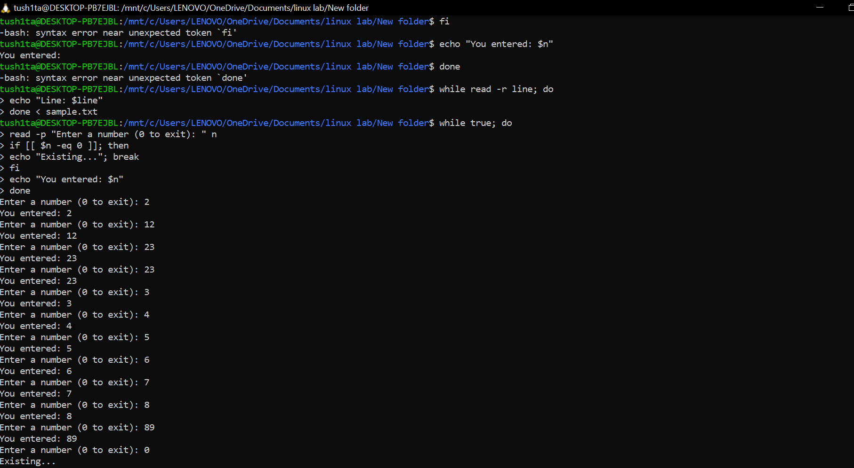

## Exercise 5: until loop

### Task Statement:

Use an until loop to run until a condition becomes true.

### Command(s):

count=1  
until [ $count -gt 5 ]; do  
 echo "count=$count"  
 ((count++))  
done

## Output:

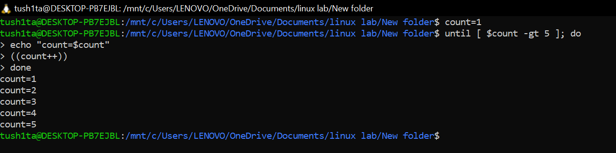

## Exercise 6: break and continue

### Task Statement:

Demonstrate break and continue inside a loop.

### Command(s):

for i in {1..10}; do  
 if [[ $i -eq 5 ]]; then  
 echo "Reached 5, breaking"; break  
 fi  
 if (( i % 2 == 0 )); then  
 echo "Skipping even $i"; continue  
 fi  
 echo "Processing $i"  
done

### Output:

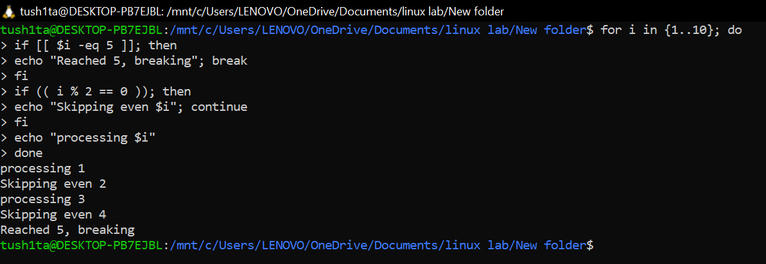

Exercise 7: Nested loops

### Task Statement:

Create nested loops to generate a multiplication table.

### Command(s):

for i in {1..3}; do  
 for j in {1..3}; do  
 echo -n "$((i*j)) "  
 done  
 echo  
done

### Output:

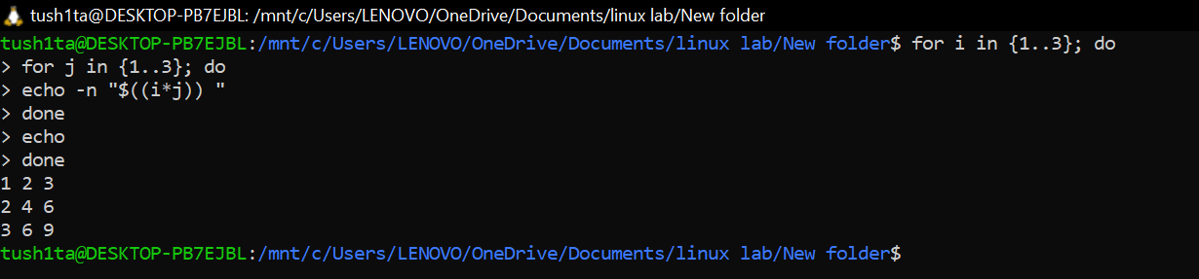

## Result

* Implemented for, while, and until loops and used loop control statements.
* Practiced reading input, processing files, and nested iteration.

## Challenges Faced & Learning Outcomes

* Challenge 1: Handling spaces and special characters when iterating filenames — learned to use quotes and read -r.
* Challenge 2: Remembering arithmetic syntax in Bash — used (( )) and expr where needed.

### Learning:

* Loops are powerful for automation in shell scripting. Correct quoting and use of control constructs prevent common bugs.

## Conclusion

The lab demonstrated practical loop constructs in Bash for automating repetitive tasks and processing data efficiently.